**Conditional Statements (If-Else) and Loops (While, For):**

1. **In the following problems you will have to draw different symbols using the asterisk (*) symbol. Each symbol has a dimension, which you will have to take as input. You will have to write two versions of code for each symbol, in version 1 you will must use nested loop, while in version 2 you cannot use nested loop.**
   1. 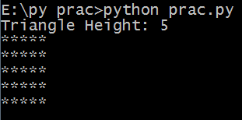
   2. 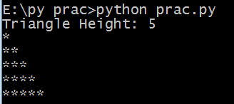
   3. 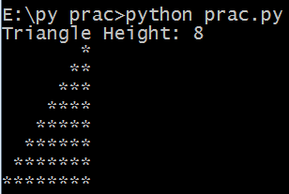
   4. 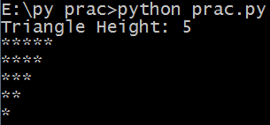
   5. 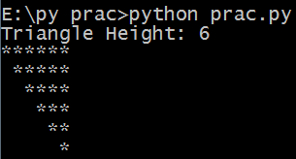
   6. 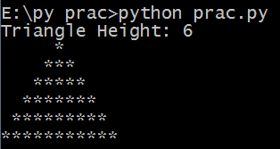
   7. **Technically, for this problem the triangle height is actually 2*input-1  
      Hint: check what range(10,0,-1) does** 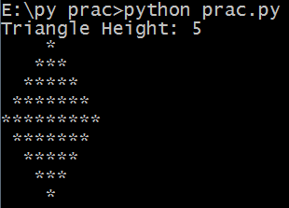
   8. **Take a binary string from user and print its decimal value**
   9. **Take a string from user, print its reverse in console without using any library function except print()**
   10. **Take a string from user, and detect whether it is a palindrome.  
       Example:  
       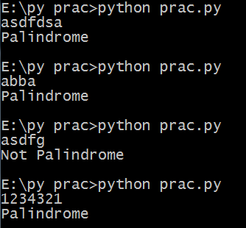**

**Files:**

1. **Create a file named “Hello.txt” using Python and write the line “Hello Python” in it. [Open the file in notepad/notepad++ to verify]**
2. **Write a Python code to open the file created in the previous task (i.e., Hello.txt) and show its content in the console.**
3. **Open the file “dummy.txt” [shared in google drive] using Python. You will have to print each sentence of that file in a separate line in console. Each sentence is ended with full stop (“.”). Your output should look like this:   
   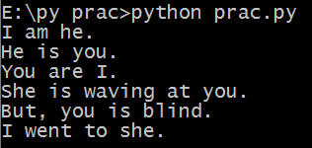**
4. **Open the csv file “marks.csv”. Print the average, max, and min marks for CT1**
5. **Open the csv file “marks.csv”. Write a Python script to find out who got the highest marks in CT1 and who got lowest in CT2 ?**
6. **Open the csv file “marks.csv”. Write a Python script to find out the total marks for each student**